[**Docker install on EC2 Ubuntu 14.04**](http://www.bogotobogo.com/DevOps/Docker/Docker_Install_On_EC2_Ubuntu.php)

**Install on EC2**

1. We need an [AWS account (http://aws.amazon.com/)](http://aws.amazon.com/).
2. Choose EC2 from [Amazon Web Services](https://console.aws.amazon.com/console/home?region=us-east-1) Console.  
   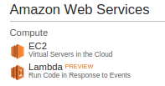
3. From [EC2 Dashboard](https://console.aws.amazon.com/ec2/v2/home?region=us-east-1), clock on Launch Instance:  
   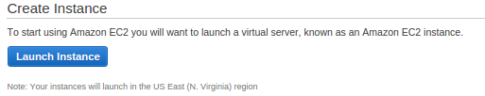
4. On the [Choose an Amazon Machine Image (AMI)](https://console.aws.amazon.com/ec2/v2/home?#LaunchInstanceWizard:) menu on the AWS Console. Click the Select button for a 64Bit Ubuntu image. (i.e. Ubuntu Server 14.04 LTS)  
   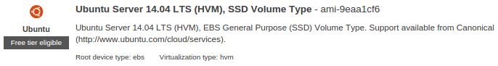
5. For testing we can use the default (possibly free) t2.micro instance (more info on [pricing](http://aws.amazon.com/ec2/pricing/)).  
   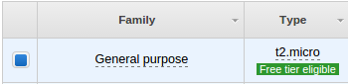
6. Click the Next: Configure Instance Details button at the bottom right.
7. On the Configure Instance Details step, expand the Advanced Detailssection.
8. Under User data, select As text.
9. Enter #include https://get.docker.com into the instance *User Data*. [CloudInit](https://help.ubuntu.com/community/CloudInit) is part of the Ubuntu image we chose; it will bootstrap Docker by running the shell script located at this URL.

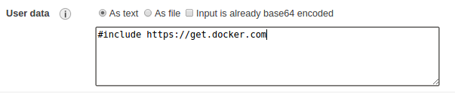

1. We may need to set up our Security Group to allow **SSH**. By default all incoming ports to our new instance will be blocked by the AWS Security Group, so we might just get timeouts when we try to connect.

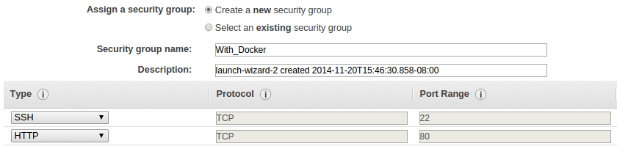

11. Creating a new key pair:

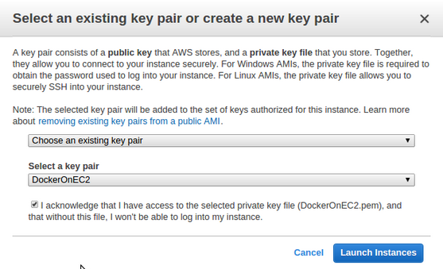

12. After a few more standard choices where defaults are probably ok, our AWS Ubuntu instance with Docker should be running!

InstanceRunning.png

1. Installing with get.docker.com (as above) will create a service named lxc-docker. It will also set up a [*docker group*](http://www.bogotobogo.com/DevOps/binaries/#dockergroup) and we may want to add the *ubuntu* user to it so that we don't have to use sudo for every Docker command.

**ssh to EC2**

k@laptop:~$ ssh -i ~/Downloads/DockerOnEC2.pem ubuntu@ec2-54-86-170-149.compute-1.amazonaws.com

The authenticity of host 'ec2-54-86-170-149.compute-1.amazonaws.com (54.86.170.149)' can't be established.

ECDSA key fingerprint is 0b:1c:d7:50:39:46:a8:95:f9:fc:26:11:b4:a2:27:a6.

Are you sure you want to continue connecting (yes/no)? yes

Warning: Permanently added 'ec2-54-86-170-149.compute-1.amazonaws.com,54.86.170.149' (ECDSA) to the list of known hosts.

@@@@@@@@@@@@@@@@@@@@@@@@@@@@@@@@@@@@@@@@@@@@@@@@@@@@@@@@@@@

@ WARNING: UNPROTECTED PRIVATE KEY FILE! @

@@@@@@@@@@@@@@@@@@@@@@@@@@@@@@@@@@@@@@@@@@@@@@@@@@@@@@@@@@@

Permissions 0640 for '/home/k/Downloads/DockerOnEC2.pem' are too open.

It is required that your private key files are NOT accessible by others.

This private key will be ignored.

bad permissions: ignore key: /home/k/Downloads/DockerOnEC2.pem

Permission denied (publickey).

We need to make the key file read-only:

k@laptop:~$ chmod 600 /home/k/Downloads/DockerOnEC2.pem

Then, try to ssh into EC2 again:

k@laptop:~$ ssh -i ~/Downloads/DockerOnEC2.pem ubuntu@ec2-54-86-170-149.compute-1.amazonaws.com

Welcome to Ubuntu 14.04.1 LTS (GNU/Linux 3.13.0-36-generic x86_64)

* Documentation: https://help.ubuntu.com/

System information as of Thu Nov 20 23:59:36 UTC 2014

System load: 0.32 Memory usage: 5% Processes: 82

Usage of /: 9.7% of 7.74GB Swap usage: 0% Users logged in: 0

Graph this data and manage this system at:

https://landscape.canonical.com/

Get cloud support with Ubuntu Advantage Cloud Guest:

http://www.ubuntu.com/business/services/cloud

0 packages can be updated.

0 updates are security updates.

The programs included with the Ubuntu system are free software;

the exact distribution terms for each program are described in the

individual files in /usr/share/doc/*/copyright.

Ubuntu comes with ABSOLUTELY NO WARRANTY, to the extent permitted by

applicable law.

ubuntu@ip-172-31-62-103:~$

**Install Docker on Ubuntu**

Though the **#include https://get.docker.com** script supposed to install Ubuntu, it seems we have to install it.

To install the latest Ubuntu package (may not be the latest Docker release):

ubuntu@ip-172-31-62-103:~$ sudo apt-get update

ubuntu@ip-172-31-62-103:~$ sudo apt-get install docker.io

Then, to enable tab-completion of Docker commands in BASH, either restart BASH or:

ubuntu@ip-172-31-62-103:~$ source /etc/bash_completion.d/docker.io

**Check if Docker is running**

We can check if the docker daemon has been started with the **status** argument:

ubuntu@ip-172-31-62-103:~$ service docker.io status

docker.io start/running, process 2732

If it's not running, we can start it with **start** argument:

ubuntu@ip-172-31-62-103:~$ service docker.io start